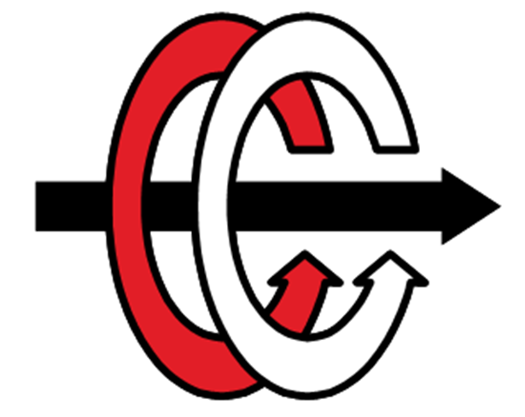

MIDDLE EAST TECHNICAL UNIVERSITY

DEPARTMENT OF ELECTRICAL AND ELECTRONICS ENGINEERING

EE463 Term Project: AC to DC Motor Drive

Simulation report

Group SoC

Canberk Kaçan

Onat Şimşek

Selen Özge Özgür

TABLE OF CONTENTS

ABSTRACT 3

INTRODUCTION & SPECIFICATIONS 3

TOPOLOGY SELECTION 3

Three phase Thyristor 4

Three phase diode rectifier and buck converter 5

Decision 5

ANALYTICAL CALCULATIONS

COMPONENT SELECTION

SIMULATION RESULTS

PCB DESIGN

CONCLUSION

REFERENCES

ABSTRACT

In order to introduce the initial design of the Term Project for the EE463 Static Power Conversion course, our SoC group has compiled this simulation report. The primary objective of the term project is to create an AC-DC converter to charge the battery by using a small wind turbine generator. This report includes potential solution approaches, provides a detailed discussion of each, simulations in the Simulink environment to meet specified requirements, selection of appropriate components based on crucial parameters, and outlines the PCB design necessary for product realization.

INTRODUCTION & SPECIFICATIONS

In this project, we are going to create a battery charging system utilizing power generated by a small wind turbine generator. The objective is to develop a design that effectively manages the input power from the wind turbine generator, ensuring a stable supply to both the load and the battery. This entails designing an AC to DC power converter circuit with the necessary control mechanisms. Since the wind speed is not constant, we need to design a system that gives the same output current while input voltage is changing. Design specifications are given below:

* Input voltage: 15
* Vline-to-line to 25
* Vline-to-line Battery capacity: 100 Ah
* Battery nominal voltage: 12 V
* Output current: 10 A
* Output current ripple: %20 of average current

TOPOLOGY SELECTION

In this section, we are going to discuss advantages and disadvantages of two topologies which are three-phase thyristor rectifier and three-phase diode rectifier+buck converter to choose which topology we are going to use.

THREE PHASE THYRISTOR

Three phase thyristor rectifiers are composed of 6 thyristors and a controller. Three phase full wave thyristor rectifier topology is given in figure 1.

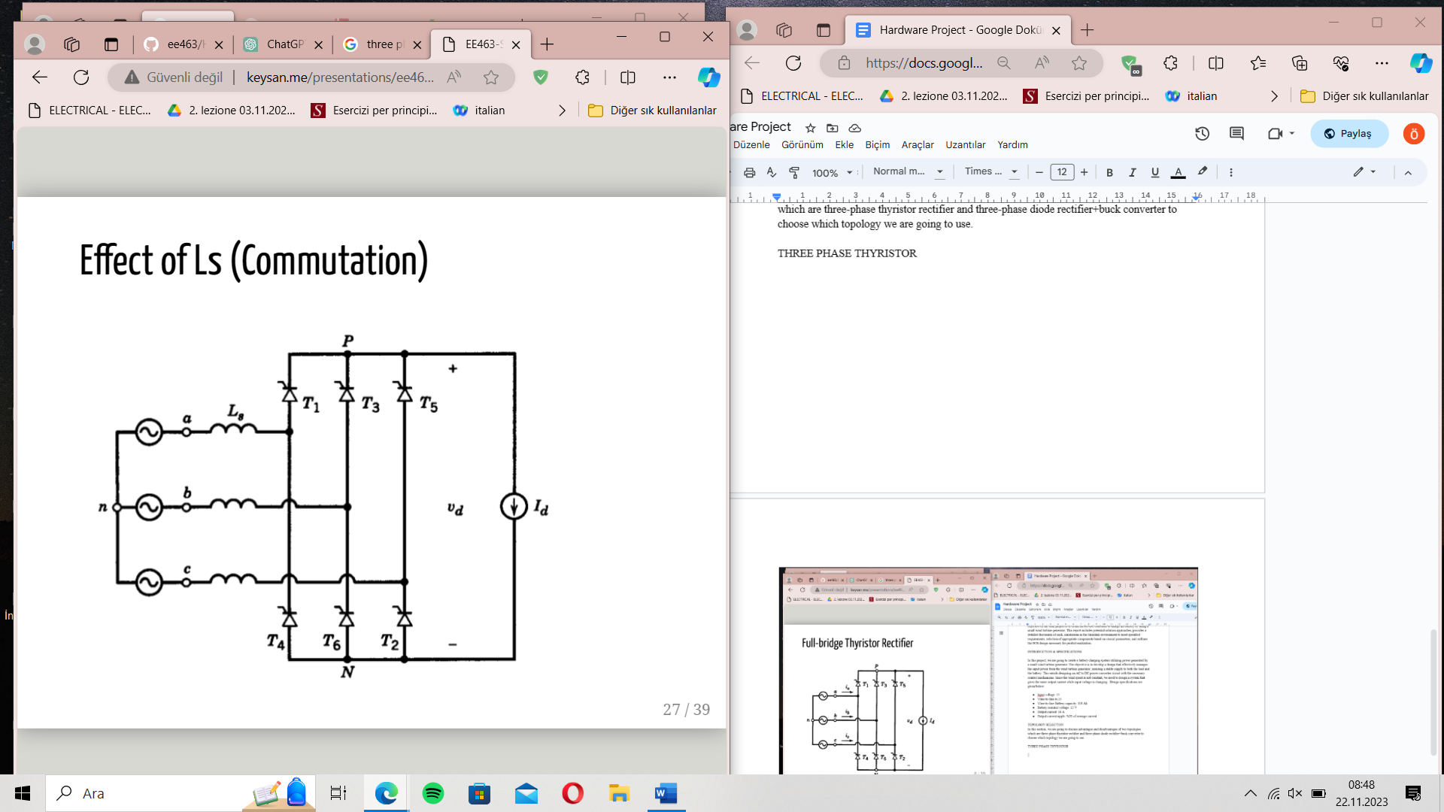

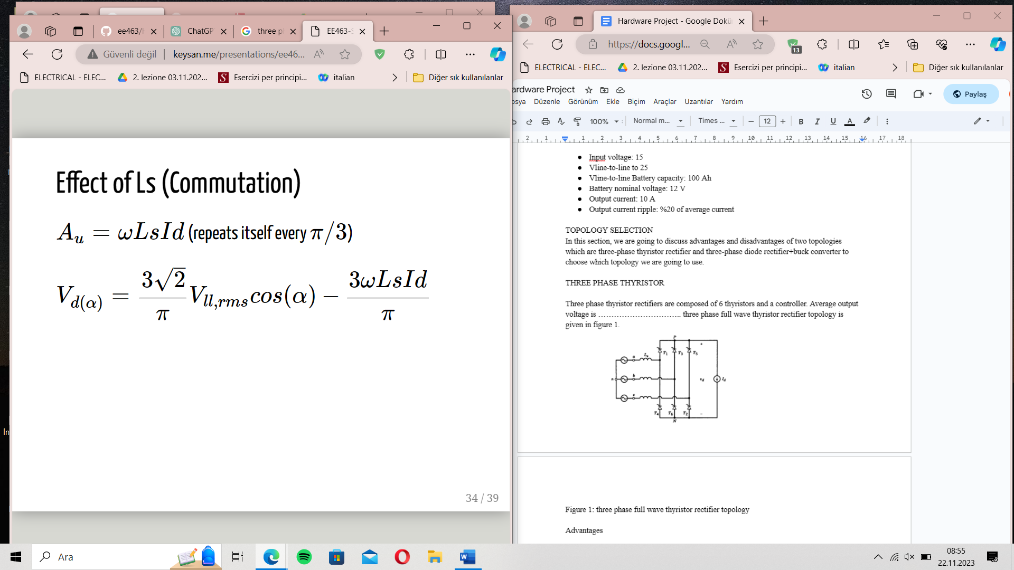

Figure 1: three phase full wave thyristor rectifier topology

Advantages

Thyristor rectifiers can handle high voltage and high current.

No need for extra topology, 6 thyristor is enough, by adjusting the fringing angle we can set the average output voltage.

Since we do not need to use capacitors and inductors, the design would be smaller and more compact.

Disadvantages

Thyristor is an expensive component and we need to use other components for control purposes which increases the cost.

We need to control 6 different thyristors by adjusting their firing angle which is possible but it is a complex procedure and will take too much time.

THREE PHASE DIODE RECTIFIER WITH BUCK CONVERTER

Three-phase diode rectifier+buck converter topology consist of 6 diodes and a buck converter. Topology is given in figure 2.

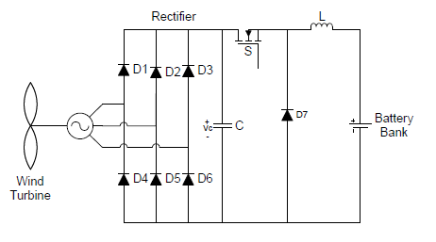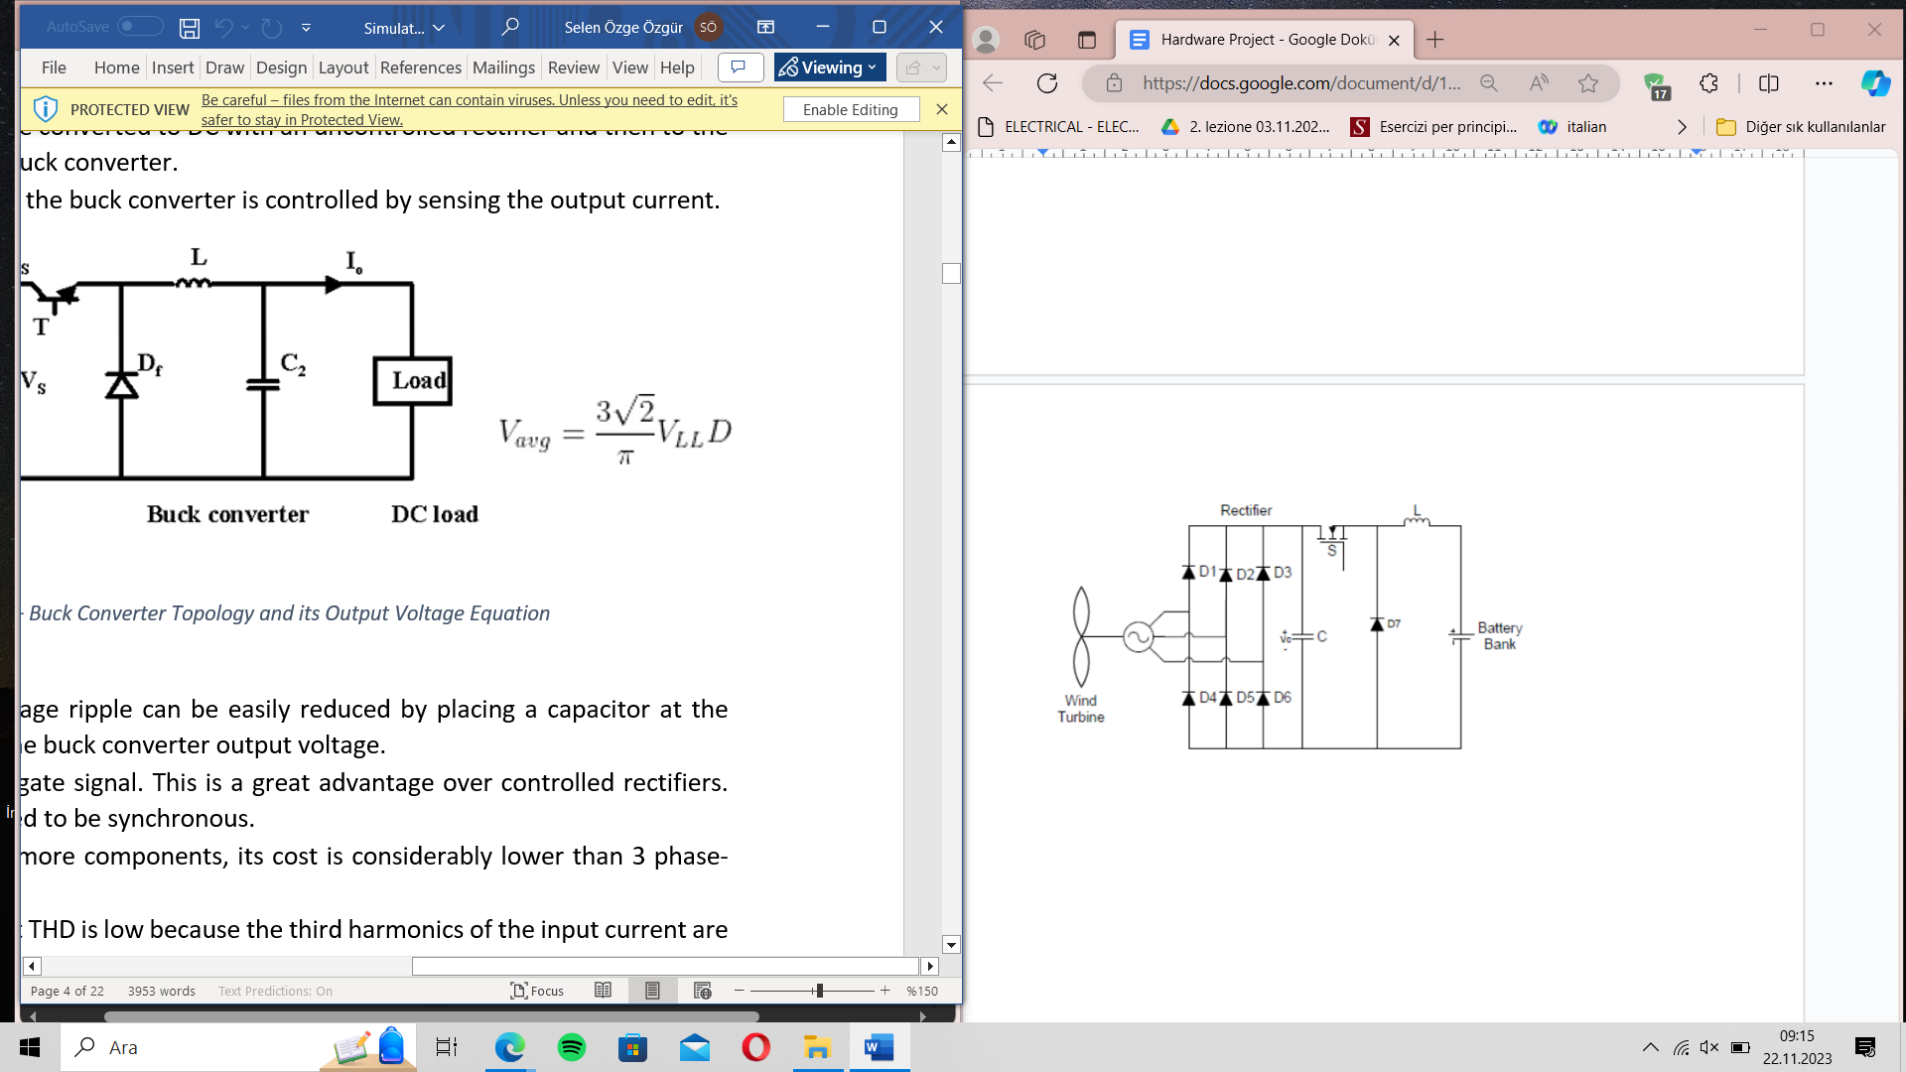

Figure 2: Three-phase diode rectifier+buck converter

Advantages

Although we use more components when we compare to the first topology, cost would not increase much when we compare with the first topology because the cost of the thyristor is much when we compare to diodes, capacitors,inductors etc.

Controlling is easy when we compare it to the first topology.

Disadvantages

Using an extra capacitor, inductor, MOSFET and a diode increases the size of the design.

May need a greater heat sink due to power MOSFET.

DECISION

As a group SoC, we are going to use three phase diode rectifiers and buck converter topology. The reasons for this choice:

Controlling is easy when we compare it to the first topology.

Thyristor's advantage is to be able to work in high current and high voltage applications but voltages and currents that we are going to work with are not that high.

We have limited time and in the following weeks, our busy periods will start. Easy implementation is a key factor to choosing this topology.